Given a string path, where path[i] = 'N', 'S', 'E' or 'W', each representing moving one unit north, south, east, or west, respectively. You start at the origin (0, 0) on a 2D plane and walk on the path specified by path.

Return True if the path crosses itself at any point, that is, if at any time you are on a location you've previously visited. Return False otherwise.

**Example 1:**

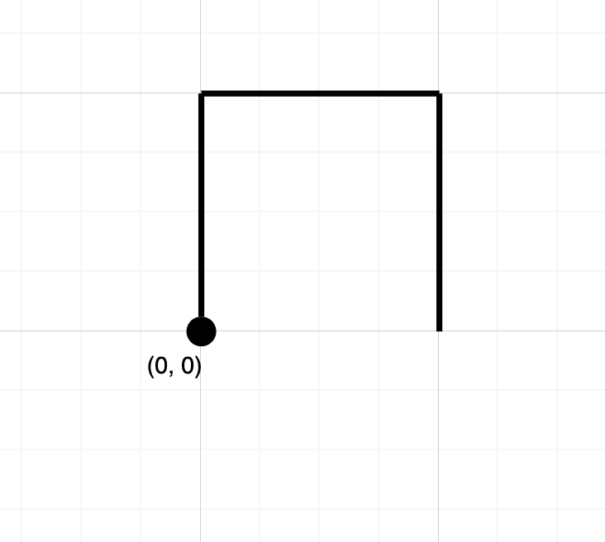

**Input:** path = "NES"

**Output:** false

**Explanation:** Notice that the path doesn't cross any point more than once.

**Example 2:**

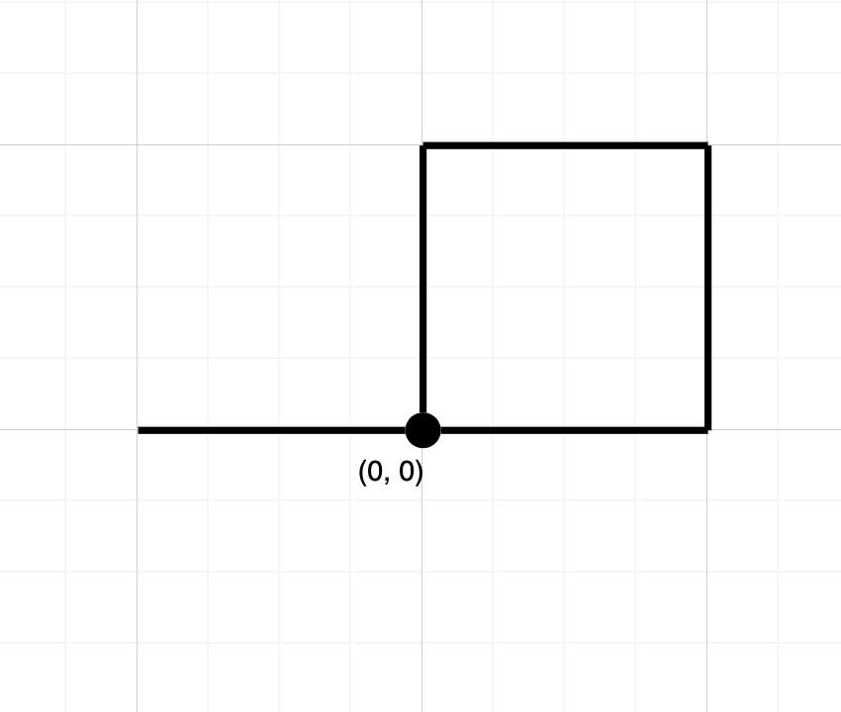

**Input:** path = "NESWW"

**Output:** true

**Explanation:** Notice that the path visits the origin twice.

**Constraints:**

* 1 <= path.length <= 10^4
* path will only consist of characters in {'N', 'S', 'E', 'W}